Published 29th. January 2021 by Jørn Watvedt for UpWork project.

Phase 0 Rev 0 Update 24 Feb 2021: Updated with information from Vu document, and prepared as final for Phase 0

31 Jan Rev 2: Added details for Raspberry PI

Joystick piloting for outboard motorboats was a popular topic 10 – 15 years ago, when the major manufacturers started developing and offering these systems. However, the excitement has much died off because of complexity, limited user benefit, high price, and the inherent limitations of big money big industry proprietary systems.

However, since then, there has been a revolution in vehicle piloting driven mostly by open-source contributions to the RC and especially RC / autopiloted drones. Now time is right for revisiting boat joystick piloting and all the current smart navigation opportunities that has become available thru ArduPilot and the associated hardware. Not only that, but quality, reliability and safety of these current technologies are certainly competitive, compared to current industrial solutions (which are 10 years old …..)

Outboard motorboats with 2 motors that are controlled independently in respect to throttle, shift, steering, and trim have vast opportunities for total boat control. Much like that recent controllers with gyro/compass/GPS/PID instrumentation made drone piloting possible, these same technologies are now ready to unleash similar transformation for outboard motorboats with 2 (or more) engines.

Now time is right to start, and start small, with a common RC boat, equipped with 2 outboard motors with independent controllers. Make it work with regular dual joystick RC controller, one joystick for each motor and a sea-trial will be convincing; Perform a sideways walk by vectoring the engines such that the resultant vector pushes the boat directly sideways. And so on!

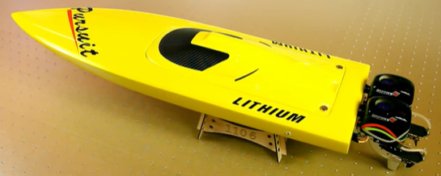

The objective of this project is to start small, start simple with current RC boat equipment and iterate and iterate and iterate. Maybe one day we feel confident to move the controller onto a full-size boat.

**Phase 0 conclusions**

as pr 24th. February 2021

**Engine conclusion:**

* Engine must mimic real boat outboard engine, hence we have decided for the following:
* Outboard hinged motor similar to real world outboard
* Steerable from servo inside boat
* Brushless motor with ESC for rotation forward/reverse
* Steering angle max required +/- 45 dgr. ( Real boat twin engine Mercury is +/-30 dgr.)

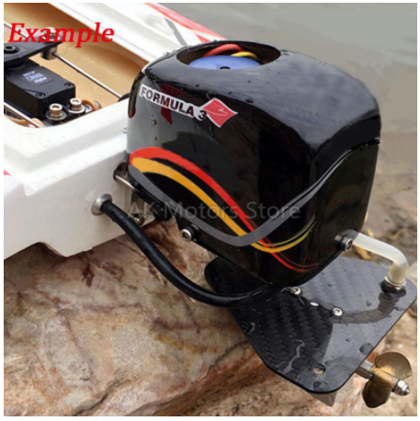

**ESC conclusion**

ESC can be purchased once, we can define the maximum power of ESC first and later on, if higher power motors if needed, we just replace the old one. 120A – 150A are sufficient to go. High range voltage input will help if we can use many kinds of battery. Battery in RC world is defined in S (series) which 1S is approximately 3.4V. Normally, ESC, motor and battery are must be synchronized. Motor and ESC maximum voltage of 6S are okay for work. Water resistance should be a point considered.

**Remote control conclusion**

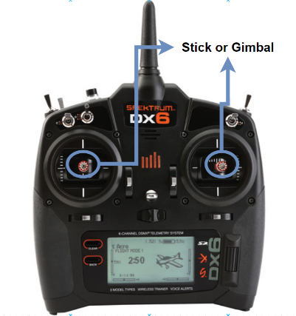In the first phases, we will manually control the boat. For 2 individual motors, we need to use 2 sticks independently. In phase 3, we will need to create an interface to transform the control input from sticks to steering mechanism of Ardupilot. More about this must be describe in detail, but in short, Ardupilot has no way to control the dual jet engine (but it has something like the document “Joystick Piloting Project by Jørn Watvedt” referred to) so that we take the advantage of those given steering by mapping our RC controller inputs.

For distinguishing, in this document, term stick or gimbal is used to describe the rod of the controller

**Vu discussion:**

The ordinary RC remote controls have 2 joysticks. Depending on typical vehicles and style of controlling, 2 joysticks can be used for multirotor, airplane, rovers… The right joystick is bounce for Up/Down and Left/Right direction which means when is move a position, by releasing, the joystick will be pulled back to the center by the spring (in side of the controller). The left joystick sometime just be bounce for Left/Right direction only, because the Up/Down is used for throttle control in multirotor or airplanes. To control 2 engines individually, we need to use both joystick simultaneously and we expect when releasing, both joystick could be bounce back to the center.

**Joern conclusion:**

For Phase 1 is ok to have “not-so-perfect” feedback/spring return, because Phase 1 is just to get a feel by sea-trials on how boat respond to engine steering and thrust. Using Sticks as they are should be OK.

**Diagram conclusion:**

Replace “servo motor for reverse bucket” with “servo motor for steering +/- 45 dgr.”

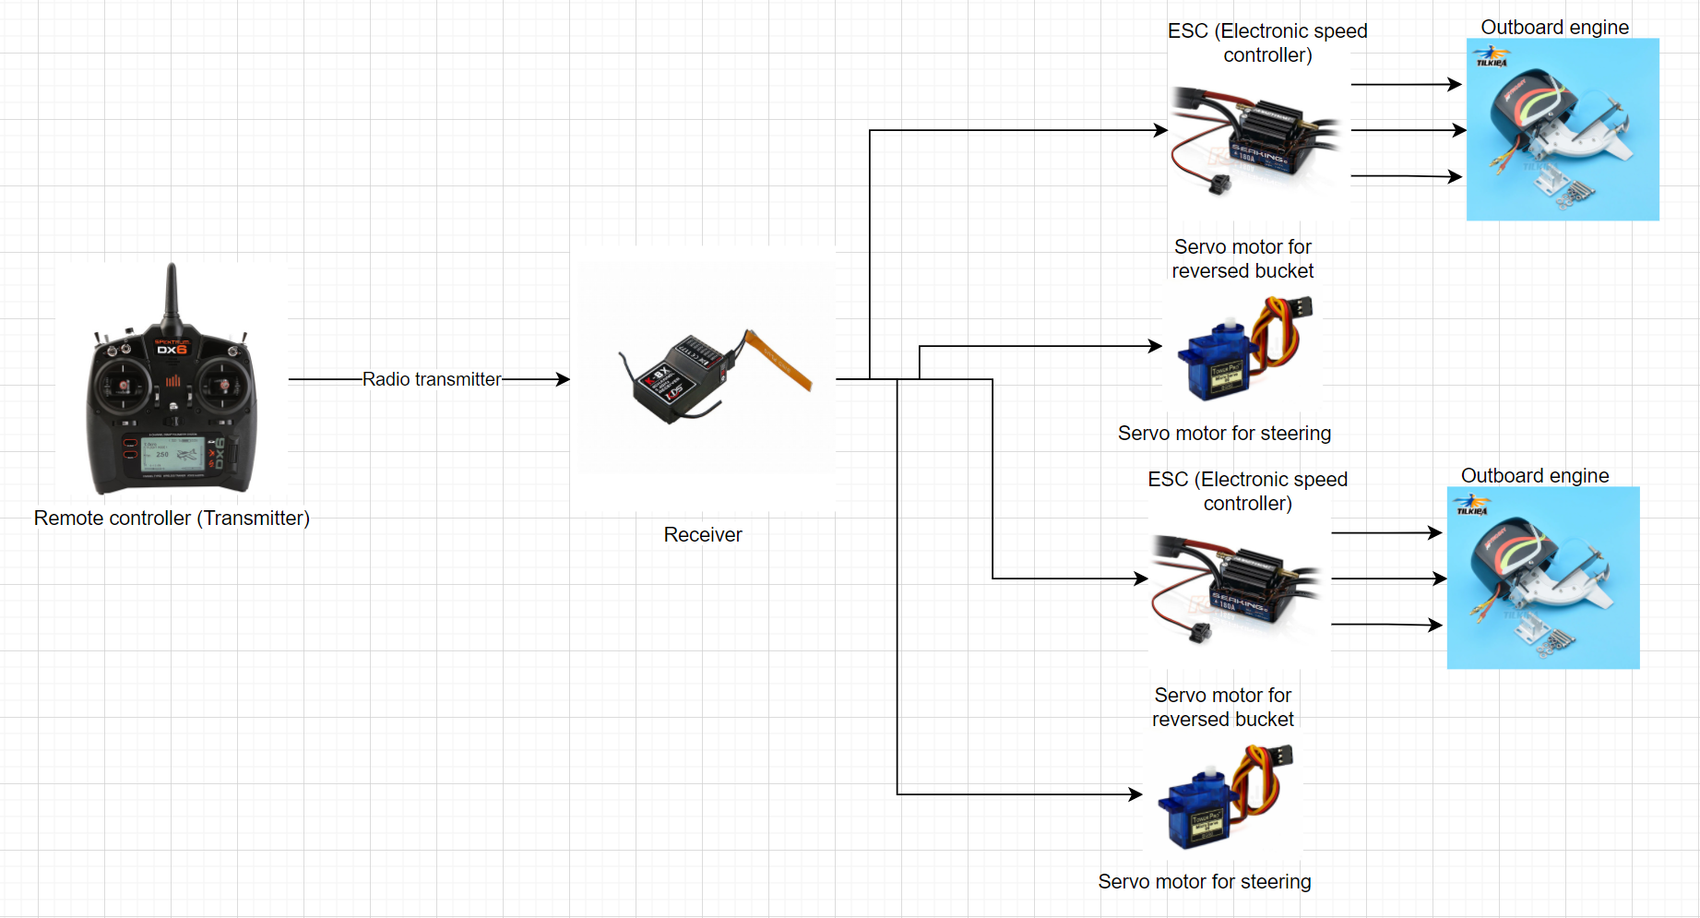

**Inspirational conclusion:**

YES, this is so true:

*Note: This is sophisticated system will be novel so far because up to now, there is no sideway movement RC boat has been observed in the internet or real life yet.*

**Chassis conclusion = Boat hull conclusion:**

Boat length shall be approximately 65 – 70 cm

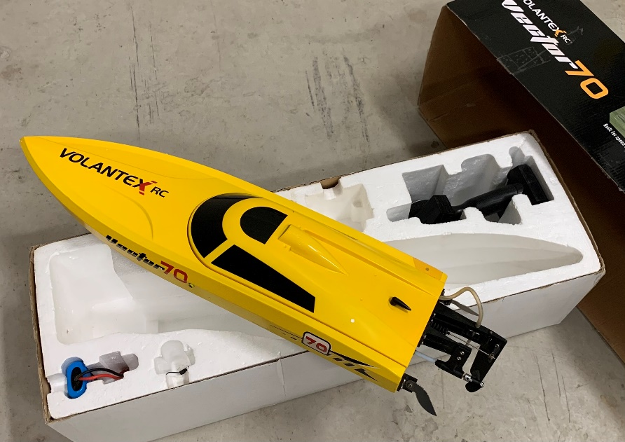Transom = rear end of boat, shall be flat area allowing installation of 2 x outboard engines and allowing the steering rods to be connected to the steering servos by using stiff metal pins.

RC boats easily flip over, to the electronics and batter should be protected inside the hull of the boat. Suggest a boat with a lid that is fairly water tight.

For next Phase, we need room for Arduino and the GPS/Gyro/Compass

**BOM Bill of Materials:**

|  |  | Quantity | Estimated Cost | Total | Remarks |
| --- | --- | --- | --- | --- | --- |
| **Engine** |  |  |  |  |  |
|  | Outboard | 2 | $100 | $200 | <https://vi.aliexpress.com/item/32878931653.html> |
| **Chassis** |  |  |  |  |  |
|  | Single hull | 1 | $50 | $50 |  |
| **Controller** | Transmitter FRSky Xlite | 1 | $155 | $155 | Kết quả hình ảnh cho frsky x lite |
|  | Transmitter FRSky QX7 | 1 | $130 | $130 | Kết quả hình ảnh cho tay qx7 |
| **Receiver** | Receiver X8R | 1 | $34 | $34 | Kết quả hình ảnh cho recevier x8r  1Km range in airbone, expected 700m in water  It has SBUS channel which is compatable to Ardupilot in the future |
| **ESC** |  |  |  |  |  |
|  | Reversible ESC | 2 | $60 | $120 | <https://www.ebay.com/itm/RW-RC-Brushless-ESC-30A-50A-70a-125a-200a-with-reversing-For-RC-car-RC-boat/174098089965?hash=item28890e07ed:g:n7wAAOSwW89d0CYr&var=472951988728>  Image 1 - RW-RC-Brushless-ESC-30A-50A-70a-125a-200a-with-reversing-For-RC-car-RC-boat |
|  | Reversible ESC | 2 | $65 | $130 | <https://vi.aliexpress.com/item/4000894083950.html?spm=a2g0o.productlist.0.0.72f1de07uw1rIs&algo_pvid=2f26114d-a82b-468b-aa6c-f0362c57516f&algo_expid=2f26114d-a82b-468b-aa6c-f0362c57516f-43&btsid=0bb0620316140682348664147ec53c&ws_ab_test=searchweb0_0,searchweb201602_,searchweb201603_> |
| **Servo** | JX Servo PDI-5513MG 13kg | 4 | $12 | $48 | <https://sea.banggood.com/JX-Servo-PDI-5513MG-13kg-Metal-Gear-High-Torque-Digital-Servo-For-RC-Models-p-1160022.html?cur_warehouse=CN>  Kết quả hình ảnh cho JX PDI-5513MG  No water proof |
|  | JX DC5821LV 20 Kg | 4  2 | $21 | $84  $42 | <https://www.ebay.com/itm/JX-Waterproof-Metal-Gear-JX-DC5821LV-20KG-Large-Torque-Digital-Coreless-Servo-/174125079363>  Image 1 - JX-Waterproof-Metal-Gear-JX-DC5821LV-20KG-Large-Torque-Digital-Coreless-Servo  Water proof |
| **Batteries** |  | 2 | $50 | $100 |  |
| **Accessories** | Glue, water cooling pipe, water pipe separator, servo link, screw… | 1 | $50 | $50 |  |

Estimated cost is $650,-

*Note: Some of the parts can be purchased secondhand for saving.*

**Process timeline Phase 1**

To be revised when parts arrive

|  |  |  |  |  |  |  |  |  |  |  |
| --- | --- | --- | --- | --- | --- | --- | --- | --- | --- | --- |
| **Weeks** | 1 | 2 | 3 | 4 | 5 | 6 | 7 | 8 | 9 | 10 |
| **Works** |  |  |  |  |  |  |  |  |  |  |
| Preparing engine |  |  |  |  |  |  |  |  |  |  |
| Preparing the chassis |  |  |  |  |  |  |  |  |  |  |
| Assembly |  |  |  |  |  |  |  |  |  |  |
| Testing and fixing |  |  |  |  |  |  |  |  |  |  |
| Sea Trials |  |  |  |  |  |  |  |  |  |  |
| Final Youtube filming |  |  |  |  |  |  |  |  |  |  |

*Note: Lead time or shipping time is not calculated yet; these could be concurrency.*

**Phase 1: RC boat with 2 outboard engines controlled by individual joysticks.**

NOT UPDATED

To be updated in accordance to actual AS BUILT when completed.

**Phase 2: Add simple controller for software vectoring of motors.**

Operational mode settings:

* Dual joystick = Forward/backward and steering individually for the motors
* Single joystick = Strict synchronized operation of motors in tandem.
* Single vectored joystick = Attempt to vector such that boat move in the joystick direction.
* Maybe ideas about other operational modes?

Objective is to be able to play with different settings and understand the dynamics of having two articulated motors.

Each operational mode probably requires a table of SETTINGS that may be updated to experiment with and better understand boat behavior.

**Phase 3: Define system hardware and software.**

Now we are ready to define with ArduPilot and what hardware to use for compass, gyro and GPS.

Issues: Cost, availability, competence required, and so on.

Ardupilot has several steering options:

<https://ardupilot.org/rover/docs/rover-motor-and-servo-connections.html>

Also different versions of vectored thrust:

<https://ardupilot.org/rover/docs/rover-vectored-thrust.html#rover-vectored-thrust>

Joystick piloting allow straight sideways movement of boat, as an illustration of what is possible, by vectoring.

Sketch explaining motor vectoring for sideways movement: Motor A and Motor B have angular direction and force, which is revectored into Ax/Ay and Bx/By respectively.

The resultant force R = Ax+Bx is pushing the boat sideways IF resultant moment from all forces around “COJ” ( Center of Joystickoperation = think of CoG Center of Gravity but for water friction forces) = 0 zero. Controller must be able to run this calculations.

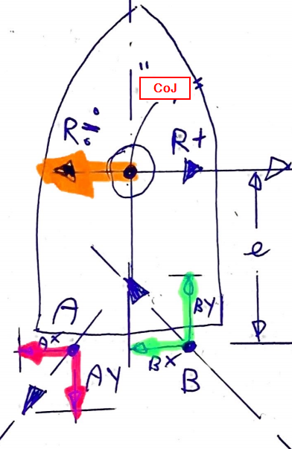

Ardupilot has several steering options:

<https://ardupilot.org/rover/docs/rover-motor-and-servo-connections.html>

Also different versions of vectored thrust:

<https://ardupilot.org/rover/docs/rover-vectored-thrust.html#rover-vectored-thrust>

**Phase 4:**

Update Boaty McBoatSurFace with new System for sea trials.

Identify issues and strategies to solve these issues.

**Phase 5:**

First full RC system

**Phase 6:**

RC System Ver 1.0

**Phase 7:**

Define Real Boat System

Real Boats us NMEA 2000 for data transfer, and there is an Open Source solution for communication:

<http://signalk.org/>

We are going to use Raspberry PI:

<https://seabits.com/nmea-2000-powered-raspberry-pi/>

**Phase 8:** Build hardware for Real Boat System.

**Phase 9:**

Develop and install software on the Real Boat System. Sea Trials

**Phase10:**

Real Boat System Ver 1.0